**Discovery Report**

ORIENT COMMERCIAL BANK

Integration

WAY4 Implementation

|  |  |
| --- | --- |
| Prepared for : | ORIENT COMMERCIAL BANK |
| Version of Document : | 1.0 |
| Status : | Draft |
| Release Date : | 9th Jan 2018 |
| Prepared by : | Openway Asia |
| Author : | Tu B. Nguyen |
| Owner : | Openway Asia |

History of Changes

|  |  |  |  |  |
| --- | --- | --- | --- | --- |
| **Version** | **Date** | **Description** | **Author** | **Approved By** |
| 1.0 | 09.01.2018 | Initial Version. | Tu B. Nguyen |  |
|  |  |  |  |  |
|  |  |  |  |  |
|  |  |  |  |  |
|  |  |  |  |  |
|  |  |  |  |  |
|  |  |  |  |  |
|  |  |  |  |  |

Copyright

© OpenWay International Limited 2018. All rights reserved.

The Copyright of this complete document and every part it belongs to OpenWay International Limited. Proprietary material, brand or product names of other parties or trademarks remain with their respective owners. You may not, except with our express written permission, distribute or commercially exploit the content. Nor may you transmit it or store it in any other website or other form of electronic retrieval system. Any sample data used in examples below are completely fictitious unless otherwise noted.

Disclaimer

This document and the OpenWay International software it describes are furnished by OpenWay International Limited under a Software Licensing Agreement, Consultancy Agreement, Variation Request or Confidentiality Agreement, and may be used or copied only in accordance with the terms of such Agreement. Neither this document nor the OpenWay International software it describes may be used, sold, transferred, copied, translated, reproduced or transmitted in any form or by any means, electronic or mechanical, for any purpose, in whole or in part, other than in accordance with the terms of such Agreement, or otherwise without prior written consent of OpenWay International Limited.

This document describes a generic product or service and should be read in conjunction with other documents relevant to the configuration of any specific system. The licensee of OpenWay software or user of OpenWay International services is responsible for ensuring that the product or service described herein meets its own requirements. The information contained in this document is subject to change without notice and should not be taken as a commitment by OpenWay International Limited. OpenWay International Limited assumes no responsibility for any errors that may appear in this document.

Confidentiality

The information contained in this Document is the property of OpenWay International Ltd and contains CONFIDENTIAL information that is produced solely for the benefit of the receiving party named on the front page of this document. The recipient should keep this document and all its information confidential. On no account should this document, in whole or in part, be used, sold, transferred, copied, translated, reproduced or transmitted in any form or by any means, electronic or mechanical, or disclosed or disseminated to any third party, without the express written permission of OpenWay International Ltd.

Table of Contents

1. Introduction 5

1.1. Purpose/Scope 5

1.2. Discovery Review Acceptance 5

1.3. Notations Used 5

2. Proposal Solution 7

2.1. REQ30001 - Proposal System Diagram 7

2.2. REQ30002 - Project Approach 7

2.3. REQ30003 - POS Vendor 8

3. POS Acquiring Product 9

3.1. REQ40001 - Client Hierarchy 9

3.2. REQ40002 - POS Product Setup 9

3.2.1. REQ400021 - POS contract subtype 9

3.2.2. REQ400022 - POS Product account scheme 10

3.3. REQ400023 - POS Product service packs 11

3.3.1. REQ4000231 - Usage 11

4. Merchant management 12

4.1. REQ50001 – Merchant Creation 12

4.2. REQ50002 – Merchant Monitoring 12

4.3. REQ50003 – POS Cycle Management 12

4.4. REQ50004 - Reference document 13

4.5. REQ50005 - GL export 14

5. POS Transaction type 15

5.1. REQ60001 - Online Purchase (Retail) 15

5.2. REQ60002 - Online Purchase Reversal 15

5.3. REQ60003 - Pre Authorization 15

5.4. REQ60004 - Pre Authorization Confirmation 15

5.5. REQ60005 - Partial Online Purchase Reversal 16

5.6. REQ60006 - Retail 2 Presentment – Manual 16

5.7. REQ60007 - Retail Adjust– Manual 16

5.8. REQ60008 - Retail Reversal – Manual 16

5.9. REQ60009 - Online Cash Advanced 16

5.10. REQ600010 - Refund Transaction 16

5.11. REQ600011 - Balance Inquiry 16

5.12. REQ600012 - Mini statement 16

5.13. REQ600013 – Purchase Key In (manual key in) 16

5.14. REQ600014 – PIN Change 16

5.15. REQ70001 - POS-POS Controller Interface 17

5.16. REQ70003 – Settlement interface (PMS) 17

5.17. REQ70003 - Merchant Statement 17

5.18. REQ70004 – Online MC Interface 18

5.19. REQ70005 – CBS Interface 18

5.20. REQ70006 – NAPAS Interface 18

6. Online Transaction Flow 19

6.1. REQ80001 – OCB Card – OCB POS Transaction 19

6.2. REQ80002 –NAPAS Card – OCB POS Transaction 19

6.3. REQ80003 – MC Card - OCB POS Transaction 20

MC Magnetic stripe Card 20

MC EMV Card 20

7. Online Transaction Specification 22

7.1. REQ90001 – Specific Fields 22

7.2. REQ90002 – Online Transaction 26

8. Daily Operation 30

8.1. REQ100001 – MC Daily Operations 30

# Introduction

## Purpose/Scope

Given discovery was elaborated as part of OpenWay WAY4 Card Management System and Switch implementation in OCB’s program. This Discovery is conducted to define the configurations, enhancements, interfacing and reports that are required in order to implement the scope of OCB Project.

This report has been prepared base on SOW document “Gap Analysis Program V1.3.doc” for list all of functions will be supported by OCB’s POS.

## Discovery Review Acceptance

On completion of the first draft, this report will be submitted to OCB for review. Comments and corrections provided will be incorporated in agreement with OpenWay, following this review.

On publication of the final version of the document, OCB will be requested to sign a Discovery Acceptance Certificate, indicating that they accept the report as an accurate description of their requirements, so far as they can be determined at the sign-off date.

Any additions or changes to the requirements detailed in the document following sign-off of the report will be agreed in accordance with the Project Agreement.

## Notations Used

|  |  |
| --- | --- |
| **Ref** | **Description** |
| AC | Acquiring Code (2 Numeric Digits). |
| AN | Alphabetic, Numeric, and Special Characters. |
| ARN | Acquirer Reference Number. |
| ATM | Automatic Teller Machine |
| B | Binary representation of data. |
| C | Conditional. |
| *C* | Numeric Check Digit, based on Luhn algorithm. |
| CDM | Cash Deposit Machine |
| CCDM | Cash and Cheque Deposit Machine |
| CMS | Card Management System |
| CR | Copy if present in request. |
| DT | Date + Format in field description. |
| EDC | Electronic Data Captured |
| IPS | International Payment System. It refers to VISA/MasterCard/American Express. |
| M | Mandatory. |
| MC | MasterCard. |
| MID | Merchant ID. |
| MR | Copy from request. |
| N | Numeric digits 0 to 9. |
| NA | Represents “Not Applicable”. |
| O | Optional. |
| OW or OPW | OpenWay |
| PBT | PIN Based Transaction. |
| POS | Point of Sales |
| RRN | Retrieval Reference Number. |
| SBT | Signature Based Transaction. |
| SIT | System Integration Test. |
| STIP | Stand In Processing |
| TID | Terminal ID. |
| UAT | User Acceptance Test. |
| BNET | Banknet |
| HIF | HIF gateway |

# Proposal Solution

## REQ30001 - Proposal System Diagram



1. WAY4 online interface between POS and POS Controller (Via OpenWay POS ISO 8583 Protocol)
2. WAY4 online interface with MC for MC EMV Cards.
3. WAY4 online interface between POS and POS Management Server (Via OpenWay PMS Protocol) for Batch Upload (If use Netserver for POS settlement function).
4. WAY4 online interface between WAY4 and WAY4 Core Banking System(HIF gateway)
5. WAY4 online interface between WAY4 and Banknet
6. WAY4 batch file interface between WAY4 and Banknet
7. WAY4 batch file interface to MC for MC Clearing and Settlement (Via MC Standard IPM file format).
8. WAY4 batch GL Balance flat file interface to WAY4 Core Banking for Merchant Settlement.

## REQ30002 - Project Approach

The project will be implemented in multiple stages. Project could be included below stages:

1. Implement POS Acquiring product.
2. Intergraded POS functions accept OCB’s Cards.
3. Intergraded POS functions accept NAPAS’s Cards.
4. Intergraded POS functions accept MC’s Cards.
5. Master Card POS EMV Acquiring Certification (certify host).
6. Master Card POS MTIP (POS device of OCB already had certification so don’t need do MTIP certification again).
7. Interface with HIF gateway (Vol 4- REQI0004).
8. Interface with NAPAS (Vol 4- REQI0003).
9. Certification with NAPAS.

## REQ30003 - POS Vendor

Currently OCB choose POS vendor VERIFONE, HYPERCOM.

# POS Acquiring Product

## REQ40001 - Client Hierarchy



Merchant includes 3-level hierarchy: Client 🡪 Main Acquiring Contract 🡪Acquiring contract -> Device Contract.

Main Acquiring contract manage merchant ID.

Under acquiring contract level have one or some POS Device contract; each POS device contract has one terminal ID. Each terminal ID has default currency is VND or USD separate.

Noted: POS 2 will support two Terminal ID, one for USD and one for VND.

## REQ40002 - POS Product Setup

## REQ400021 - POS contract subtype

#### Contract number at Branch:

**Main Acquiring contract**

XXXM000000 to XXXM999999

**Acquiring contract**

XXXB000000 to XXXB999999

**POS Device Contract (Terminal ID)**

00000000 to 00099999

XXX: Three digits at last Branch code (ex: 0123 -> XXX=123)

#### Contract number on market:

**Main Acquiring contract**

XXXM000000 to XXXM999999

**Acquiring contract**

XXXP00000 to XXXP999999

**POS Device contract (Terminal ID)**

00000000 to 00099999

XXX: Three digits at last Branch code (ex: 0123 -> XXX=123)

## REQ400022 - POS Product account scheme

* Level main Acquiring contract supports manage all of acquiring contract under level. Can create report manage total transaction and manage all of POS device under level.
* Level Acquiring contract will support one default currency and had been configured in service package. At this level depend on currency support will use Account scheme USD or VND.

For GL Balancing WAY4 requires the below account and following GL entries:

Under IPS Scheme we will have

* GL Account for VISA Payable VND
* GL Account for VISA Receivable VND
* GL Account for MC Payable VND
* GL Account for MC Receivable VND

Under Revenue Accounts we will have

* GL Account for MDR Fee Account for Banknet
* GL Account for MDR Fee Account for MC
* GL Account for MDR Fee Account for VISA
* GL Account for MDR Fee Account for WAY4
* GL Account for Fees Account[1]

For WAY4 Cards

* GL number to define WAY4 Cards
* WAY4 Suspense Account (WAY4 Onus Chargeback) – can have same GL Account as WAY4 Payable-Card Dispute Account

For Merchants

* Merchant Receivable
* Merchant Payable
* Merchant Dispute
* Fees

Merchant Payment

* GL Number to Post the Payment

Merchant GL Number

* Each Merchant will have GL Number to post the payment to it

Way4 support MC Cards‘s transactions with dual message following Master Card standard.

The authorization at POS must be settled successfully by the merchant before going to further processing such as credit to Merchant, debit to cardholder if onus card OR outgoing file generation for offus card.

## REQ400023 - POS Product service packs

## REQ4000231 - Usage

It will be possible to configure separate MCC limits for on us, Domestic issuer mode and International Issuer mode transactions.

* Maximum amount of transaction
* Daily limit on total amount of transactions
* Periodic limit on total amount of transactions

|  |  |  |  |  |
| --- | --- | --- | --- | --- |
| # | **Card Type** | **Transaction Type** | **Usage Type** | **Value** |
| 1 | NAPAS Cards | Cash Advance | Single Amount | 2,000,000 |
| 2 | MC Cards | Cash Advance | Single Amount | 2,000,000 |

Currently OCB don’t apply usage for POS Acquiring product. Openway will provide guide document support OCB can create configuration usage in future.

#### Merchant Discount Rate

CMS shall support following discount calculation algorithms base on transaction:

* Fixed amount per transaction.
* Multiple rate base on transaction amount

|  |  |  |  |
| --- | --- | --- | --- |
| # | **POS Type** | **Card Type** | **MDR Rate** |
| 1 | POS Sale | NAPAS Cards | 0.12 |
| 2 | POS Sale | OCB Domestic Cards | 0.00 |
| 3 | POS Cash at Branch | NAPAS Cards | 0.00 |
| 4 | POS Sale | MasterCard | 1.80 |
| 5 | POS Cash at Branch | MasterCard | 0.00 |
| 7 | POS Cash at Branch | OCB Domestic Cards | 0.00 |

Way4 supports export payment file daily for merchant.

# Merchant management

WAY4 allow OCB Staffs to see all authorization transactions in WAY4.

WAY4 allow OCB staffs to see all transaction status and merchant information, device information, errors transactions (error code and detail error).

## REQ50001 – Merchant Creation

Way4 allow create new POS Merchant by manual, when merchant created default MDR will be specified in service package (Acquiring product). If Bank want to apply individual MDR for each merchant, it could be done by Tariff module.

## REQ50002 – Merchant Monitoring

Bank staffs monitor status of POS device via POS monitor screen:

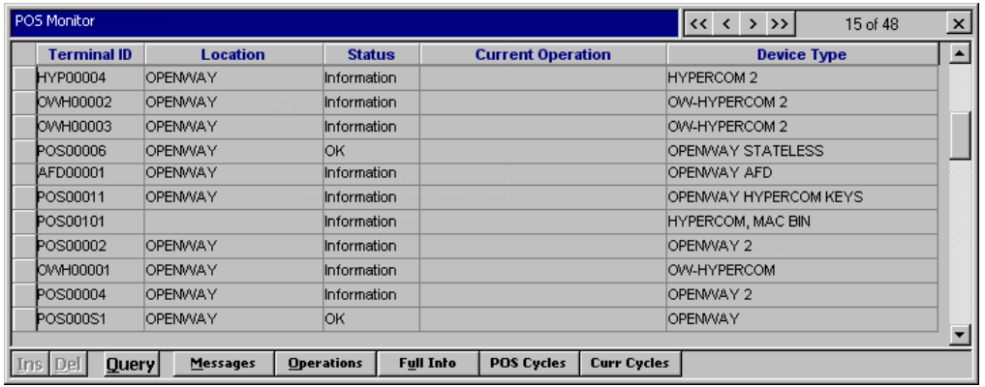

Way4 allow bank staffs can active or inactive operation of POS by change status

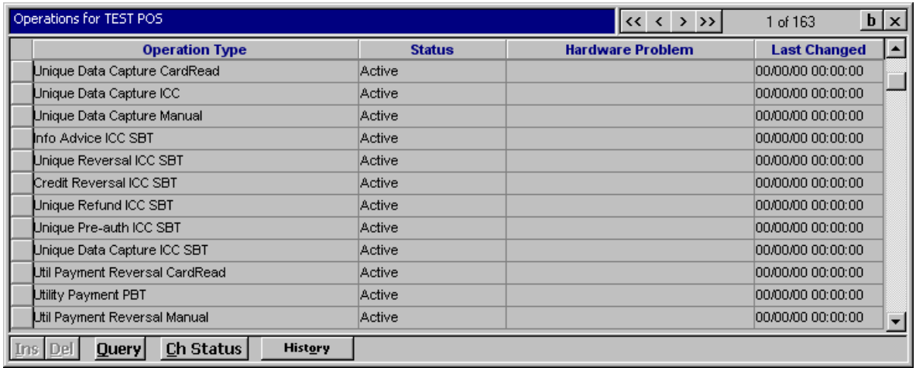

## REQ50003 – POS Cycle Management

Way4 allow Bank can manage all of POS cycle at current and history

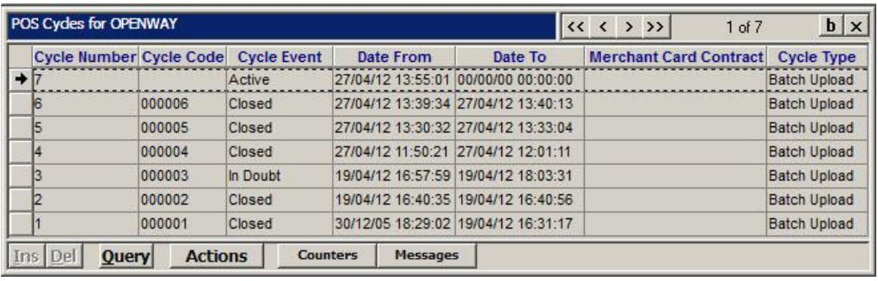

Under each cycle (history cycle and current cycle) Bank can check total debit and credit amount, number of transaction, more detail of transaction in the cycle…

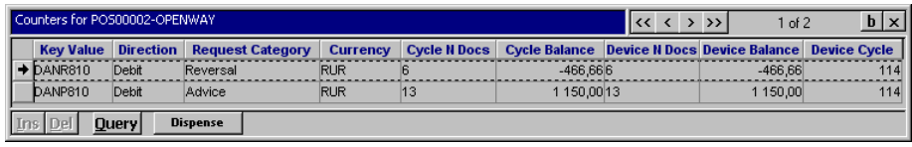

Bellow is detail and link to document for each transaction in the POS cycle:

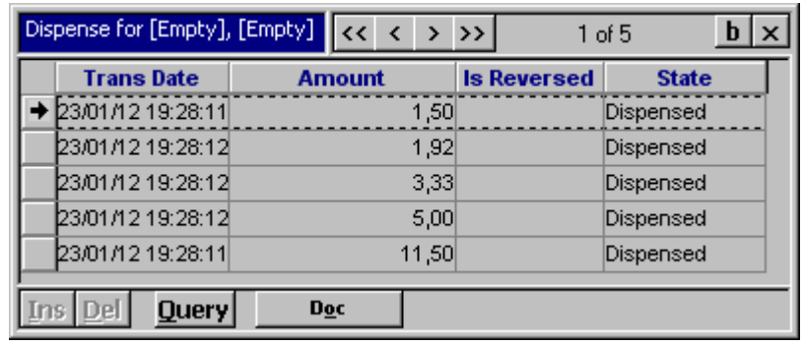

## REQ50004 - Reference document

Openway provides the document description more detail support manage Merchant and POS management as the attached bellow:



## REQ50005 - GL export

At the end of the day bank staff run GL export menu for export GL file to core banking. File sample:



# POS Transaction type

WAY4 will support the following financial transactions types as listed in the table below.

|  |  |  |  |  |  |
| --- | --- | --- | --- | --- | --- |
| # | **Transaction Type** | **Currency** | **OCB** | **BNET** | **MC** |
| 1 | Online Purchase (Retail) | VND/USD | Yes | Yes | Yes |
| 2 | Online Purchase Reversal (Retail Reversal) | VND/USD | Yes | Yes | Yes |
| 3 | Pre Authorization | VND/USD | Yes | Yes | Yes |
| 4 | Pre Authorization Confirmation | VND/USD | Yes | Yes | Yes |
| 5 | Partial Online Purchase Reversal (Adjustment) | VND/USD | Yes | Yes | Yes |
| 7 | Retail Adjust-Manual | VND/USD | Yes | Yes | Yes |
| 8 | Retail Reversal-Manual/void | VND/USD | Yes | Yes | Yes |
| 9 | Cash Advanced | VND/USD | Yes | Yes | Yes |
| 10 | Funds Transfer | VND | No | No | No |
| 11 | Refund | VND/USD | Yes | Yes | Yes |
| 12 | Online Purchase Key In | VND | Yes | Yes | Yes |
| 13 | Void | VND/USD | Yes | Yes | Yes |

Transaction non-Financial

|  |  |  |  |  |  |
| --- | --- | --- | --- | --- | --- |
| # | **Transaction Type** | **Currency** | **OCB** | **BNET** | **MC** |
| 1 | Balance Inquiry |  | Yes | Yes | Yes |
| 2 | Mini Statement |  | No | No | No |
| 3 | Pin Change |  | Yes | Yes | No |

Bank has facility to configure each POS can or cannot do one or more specific transaction(s).

## REQ60001 - Online Purchase (Retail)

WAY4 merchant can initiate purchase transaction from WAY4 POS. The transaction apply for all OCB, BNET and MC Card (MS and EMV Cards).

When customer purchase at hotel can push tip amount before send request transaction (TIP amount stored in TAG 38 in field 54 Additional amount).

## REQ60002 - Online Purchase Reversal

WAY4 merchant can initiate reversal of Purchase transaction or Pre Authorization transaction. Or POS can send an auto reversal message of Purchase transaction in case time out.

## REQ60003 - Pre Authorization

WAY4 merchant can request to block some amount for WAY4/MC cardholders on POS when merchant needs cardholders deposit before doing something.

## REQ60004 - Pre Authorization Confirmation

If VISA/MC cardholder agrees to pay the same amount of a previous pre authorization transaction, WAY4 merchant can use this function in POS to create an appropriate financial transaction.

## REQ60005 - Partial Online Purchase Reversal

WAY4 merchant can adjust transaction amount in the predefine range of WAY4 at POS.

## REQ60006 - Retail 2 Presentment – Manual

WAY4 staffs can access menu Doc in WAY4 Client Application (WAY4 Manager) to select a MC chargeback transaction (imported into WAY4 in MC IPM files) and then click Doc Brief after that choose Cbk/Presentment function to create 2nd Presentment transactions in WAY4.

## REQ60007 - Retail Adjust– Manual

WAY4 staffs can access menu Doc to select a MC financial transaction and then click Doc Brief after that choose Adjust function to perform adjustment in WAY4.

## REQ60008 - Retail Reversal – Manual

WAY4 staffs can access menu Doc to select a MC financial transaction and then click Doc Brief after that choose Reversal function to perform Charge Back in WAY4.

## REQ60009 - Online Cash Advanced

Cash Advanced Transaction is activated for some devices.

## REQ600010 - Refund Transaction

Refund is used to credit a cardholder account. This is used when the original transaction cannot be reversed by a Cancelling, Universal Reversal or Universal Reversal Advice transaction; for instance, in case a negative response has been received on a Universal Reversal transaction request, this message is sent when refunds are processed on-line.

## REQ600011 - Balance Inquiry

The balance inquiry transaction allows the cardholder’s account balance to be checked without funds being blocked on the account.

## REQ600012 - Mini statement

Mini statement transactions allow cardholders to check activity on the account.

## REQ600013 – Purchase Key In (manual key in)

This function allow cardholder can do transaction when card not present, Cardholder provide card number, expire date.

## REQ600014 – PIN Change

Way4 System Interface

| **No** | **Type** | **Description** | **Document Reference** |
| --- | --- | --- | --- |
| 1. | POS – POS Controller Interface | WAY4 POS OPENWAY Dialect will be used for the interface. | REQ70001 |
| 2. | POS – POS Management Server Interface | WAY4 POS Management Protocol will be used for the interface (in case using Netserver). | REQ70002 |
| 3. | Merchant Statement File Interfacing | WAY4 will be configured to generate the flat file to create Merchant Statement. | REQ70003 |
| 4. | MC Online | WAY4 will need to be configured to interface with MC as described in MC Customer Interface Specification and IPM Clearing File Format. | REQI0004 |
| 5. | CBS Interface | WAY4 will need to be configured to interface with CBS as described in CBS specification. | REQI0005 |
| 6. | NAPAS interface | WAY4 will need to be configured to interface with NAPAS as described in NAPAS specification. | REQ70006 |

The solution should have capability to manage TMK for each of Terminal ID. The session key will be exchanged as required.

## REQ70001 - POS-POS Controller Interface

**Business Requirement**

Apply WAY4 POS Hypercom ISO8583.

**Technical Detail**

POS connects to WAY4 Net-Server Channel.

**Reference**

ISO 8583, Existing POS Message

## REQ70002 – Settlement interface (PMS)

**Business Requirement**

Apply WAY4 POS Hypercom ISO8583.

In case use transaction switch will don’t need implement interface with PMS.

**Technical Detail**

POS connects to PMS via iso8583 standard message.

**Reference**

ISO 8583, Existing POS Message

## REQ70003 - Merchant Statement

**Business Requirement**

Apply WAY4 Standard Merchant Statement

**Technical Detail**

Using the menu: OpenWay\Full\Customer Support\Statements\Merchant Batch Statements\Batch Merchant Statements

**Reference**

OWS_HOME\manuals\english\acquiring\user manuals\Merchant_Statements.pdf



## REQ70004 – Online MC Interface

**Business Requirement**

POS vendor must develops message sent to Way4 following MC specification

**Technical Detail**

Following MC Specification

**Reference**

## REQ70005 – CBS Interface

**Business Requirement**

Way4 has H2H channel interface with CBS and POS vendor will develops message following specification apply for transaction send to CBS

**Technical Detail**

Following CBS Specification in Volume 6.

**Reference**

## REQ70006 – NAPAS Interface

**Business Requirement**

POS vendor must develops message sent to Way4 following NAPAS specification

**Technical Detail**

Following NAPAS Specification in Volume 6.

**Reference**

# Online Transaction Flow

## REQ80001 – OCB Card – OCB POS Transaction

1. Merchant will swipe card on OCB POS terminal
2. Merchant will select Purchase transaction from the menu
3. Merchant will enter the purchase amount and confirm
4. POS will send transaction request to WAY4 switch
5. After receiving transaction request, WAY4 switch will identify that card is Local Debit card/ Prepaid Card / MC Card. WAY4 switch will route the transaction to authorization module.
6. Authorization module will verify card data, PIN, Available...
   1. If successful and card type is Debit Card, message will be routing to core Banking, in case is prepaid card and MC card message response will be return to POS channel.
   2. If unsuccessful depend on the error reason Way4 will responses error code to POS channel
7. WAY4 switch will forward the response to POS
   1. If unsuccessful response received, POS will display reject response and print the receipt to complete the transaction
   2. If successful response received, POS will display approved response and print the receipt to complete the transaction
8. In case of time out between WAY4 switch and POS, WAY4 switch will send reject response to POS and reversal to Authorization module.

## REQ80002 –NAPAS Card – OCB POS Transaction

1. Merchant will swipe card on OCB POS terminal.
2. Merchant will select Purchase transaction from the menu.
3. Merchant will enter the purchase amount and confirm.
4. POS will send transaction request to WAY4 switch.
5. After receiving transaction request, WAY4 switch will identify that card belongs to NAPAS network. WAY4 switch will route the transaction to NAPAS for authorization.
6. NAPAS will forward the transaction to corresponding issuer for authorization
7. Issuer will perform authorization and send response to NAPAS network.
8. NAPAS will forward the response received from issuer to WAY4 switch.
9. WAY4 switch will forward the response to POS
   1. If unsuccessful response received, POS will display reject response and print the receipt to complete the transaction
   2. If successful response received, POS will display approved response and print the receipt to complete the transaction
10. In case of time out between WAY4 switch and NAPAS, WAY4 switch will send reject response to POS and reversal to NAPAS network

In case of time out with POS, POS will reject the transaction and send reversal to WAY4 switch. WAY4 switch will forward reversal to NAPAS network.

## REQ80003 – MC Card - OCB POS Transaction

### MC Magnetic stripe Card

1. Merchant will swipe card on OCB POS terminal
2. Merchant will select Purchase transaction from the menu
3. Merchant will enter the purchase amount and confirm
4. POS will send transaction request to WAY4 switch
5. After receiving transaction request, WAY4 switch will identify that card belongs to MasterCard network. WAY4 switch will route the transaction to MasterCard for authorization
6. MasterCard will forward the transaction to corresponding issuer for authorization
7. Issuer will perform authorization and send response to MasterCard network
8. MasterCard will forward the response received from issuer to WAY4 switch
9. WAY4 switch will forward the response to POS
   1. If unsuccessful response received, POS will display reject response and print the receipt to complete the transaction
   2. If successful response received, POS will display approved response and print the receipt to complete the transaction
10. In case of time out between WAY4 switch and MasterCard, WAY4 switch will send reject response to POS and reversal to MasterCard network
11. In case of time out with POS, POS will reject the transaction and send reversal to WAY4 switch. WAY4 switch will forward reversal to MasterCard network.

### MC EMV Card

1. Merchant will insert chip card on OCB POS terminal. Once the card is inserted chip initialization will take place
2. POS terminal will display transaction menu
3. Merchant will select Purchase transaction from the menu
4. Merchant will enter the purchase amount and confirm
5. POS will send transaction request to WAY4 switch with ARQC
6. After receiving transaction request, WAY4 switch will identify that card belongs to MasterCard network. WAY4 switch will route the transaction to MasterCard for authorization. MasterCard will forward the transaction to corresponding issuer for authorization
7. Issuer will perform authorization and send response to MasterCard network with ARPC
8. MasterCard will forward the response received from issuer to WAY4 switch
9. WAY4 switch will forward the response to POS
10. On receiving the response, card will validate the ARPC
    1. If ARPC validation is successful, POS will display approved response and print the receipt to complete the transaction
    2. If ARPC validation is unsuccessful, transaction will be rejected. In this case if successful response is received, reversal will be generated and sent to MasterCard.
11. In case of time out between WAY4 switch and MasterCard, WAY4 switch will send reject response to POS and reversal to MasterCard network

In case of time out with POS, POS will reject the transaction and send reversal to WAY4 switch. WAY4 switch will forward reversal to MasterCard network.

# Online Transaction Specification

Openway provides update version following Master Card’s requirement.

## REQ90001 – Specific Fields

**F11: System Trace Audit Number**

This audit number should have non zero value.

**F22: POS Entry Mode**

The POS Entry Mode has to be filled according to current transaction conditions or can be inherited from original message (for secondary operations). The valid values for the field are following:

051 – Chip Read, PBT (online & offline PIN)

052 – Chip Read, SBT

801 – Fallback, Full Track Read, PBT

802 – Fallback, Full Track Read, SBT

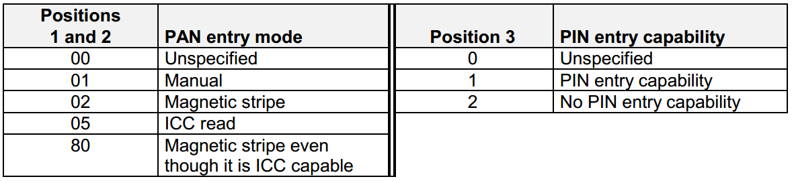

**F23: Card Sequence Number**

The Card Sequence number is a mandatory field for ICC-originated transactions if the data is provided by smart card (EMV Tag 5F34).

**F25: POS Condition Code**

The POS Condition Code has to be filled according to current transaction conditions or can be inherited from original message (for secondary operations).

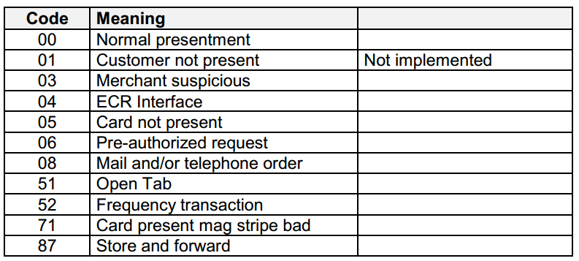

**F54: Additional Amount**

The Additional Amounts field contains other amounts associated with the transaction. When processing restaurant transactions this field contains the tip.



**F55: ICC Related Data**

The ICC-Related data can consist of a set of the following sub-fields. Each subfield is coded in BER-TLV format as described in EMV.

The contents of field 55 in an authorization (MTID = 01xx) or financial (MTID = 02xx) request with its response are listed below:

|  |  |  |  |  |
| --- | --- | --- | --- | --- |
| POS Message Type | Tag | Length | Value | Comments |
| REQUEST | 9F26 | 8 | Application Cryptogram | Mandatory |
| 9F27 | 1 | Cryptogram Info | Mandatory;  80 – PIN Change Request,  PIN Enrolment Request  If not provided by ICC (e.g.  PayWave VCPS 2.0.2), it can be  obtained from CVR (included in tag  9F10, byte 5) |
| 9F10 | VAR | Issuer Application Data  Contains Derivation Key Index  concatenated with  Cryptogram Version, CVR  and DAC (M/CHIP) and Issuer  Discretionary Data (M/CHIP4  and VSDC+ offline counters  etc.). | Mandatory, if provided by ICC |
| 9F37 | 4 | Unpredictable Number | Mandatory |
| 9F36 | 2 | ATC | Mandatory |
| 95 | 5 | TVR | Mandatory |
| 9A | 3 | Transaction Date | Mandatory |
| 9C | 1 | Transaction Type | Mandatory |
| 9F02 | 6 | Transaction Amount | Mandatory |
| 5F2A | 2 | Transaction Currency Code | Mandatory |
| 82 | 2 | Application Interchange  Profile | Mandatory |
| 9F1A | 2 | Terminal Country Code | Mandatory |
| 9F03 | 6 | Amount Other | Mandatory for cash-back amounts,  and if EMV Tag 9F03 Provided by  terminal |
| 9F33 | 3 | Terminal Capabilities | Mandatory |
| 4F | VAR | Application ID | Optional |
| 9F08 | 2 | Application Version Number | Optional |
| 9F34 | 3 | CVM Results | Mandatory |
| 9F35 | 1 | Terminal Type | Optional |
| 9F1E | 8 | IFD Serial Number | Optional |
| 9F53 | 1 | Transaction Category Code | Optional |
| 84 | VAR | Dedicated File Name | Optional |
| 9F09 | 2 | Terminal Application Version  Number | Optional |
| 9F41 | VAR | Transaction Sequence  Counter | Optional |
| CB | 6 | Upper Cumulative Offline  Amount Limit | Optional |
| RESPONSE | 91 | VAR | Issuer Authentication Data | Optional |
| 71 | VAR | Issuer Script Template 1 | Optional (Could be several scripts) |
| 72 | VAR | Issuer Script Template 2 | Optional (Could be several scripts) |

The contents of field 55 in a Reversal (MTID = 0420) requests are listed below:

|  |  |  |  |  |
| --- | --- | --- | --- | --- |
| POS Message Type | Tag | Length | Value | Comments |
| REQUEST | 9F10 | VAR | Issuer Application Data  Contains Derivation Key Index  concatenated with Cryptogram  Version, CVR and DAC  (M/Chip). | Mandatory, if provided by ICC and Issuer Authentication  Failed |
| 95 | 5 | TVR | Mandatory, if Issuer  Authentication failed |

**F63: Additional Data**

Additional data can consist of one or more of the fields below immediately following each other in sequence. Each field contains its own length indicator and tag to allow any fields that are not recognized by the host to be stepped over and ignored, with any subsequent fields still processed successfully.

|  |  |  |
| --- | --- | --- |
| **#** | **TAG** | **Tag abbreviation** |
| 1 | Tax Record Number | TR |
| 2 | Secret Code | SC |
| 3 | Additional Host Print Data/Formatted Receipt Data | 29 |
| 4 | Reference Information | RI |
| 5 | Pin Encrypted Under Session Key | PE |
| 6 | Purchase Points | PP |
| 7 | Issuer Bank Name | IB |
| 8 | Beneficiary Bank Name | BB |
| 9 | Cardholder Name | CH |

## REQ90002 – Online Transaction

**Pre Authorization**

By this operation, the response code is received from the client issuer system and the defined amount is blocked on the cardholder’s account. The terminal should print a receipt with the result of operation and reference values. The receipt should NOT be signed by the cardholder because the host will NOT INITIATE any fund transfer operations from the cardholder’s bank. The transaction will be pending.

*The detail of this transaction is mentioned at section Authorization in attached OpenWay POS ISO 8583 Dialect (Basic Set).*

**Pre Authorization Confirmation**

This transaction confirms the previous authorization and makes the ACQUIRER HOST aware that an operation has been initiated requesting fund transfer from the cardholder’s bank. The terminal should print out a receipt with the result of the operation and reference values indicated. The receipt should be signed by the cardholder and is the main document for possible dispute situations involving signature-based transactions.

Some fields have specific values: **Field 24 containing value "202"**

*The detail of this transaction is mentioned at section Authorization Confirmation in attached OpenWay POS ISO 8583 Dialect (Basic Set).*

**Purchase/Cash Advance**

By this operation, a response code is received from the client issuer system and the specified amount is blocked on the cardholder’s account. The terminal should print a receipt indicating operation results and reference values. The receipt should be signed by the cardholder and is the main document for possible dispute situations involving signature-based transactions. Hosts will automatically INITIATE operations for requesting money from cardholder bank. This is a general POS operation.

*Note: Purchase POS and Cash Advance POS will have difference Terminal IDs. However, they are belong to the same POS physical device. Base on selected function, POS application will know to send Purchase ID or Cash Advance ID to WAY4.*

**Universal Reversal Advice/Adjustment**

Reversal message is intended for reversing of any transaction, which can be reversed.

Some fields have specific values.

* + Field 2 If original operation is CREDIT, must contain the merchant card number.
  + Field 4 If original operation is PURCHASE WITH CASH BACK, must contain value less or equal to authorized (returned in response) amount in original operation. In case of full automatically-generated reversal advice for operation PURCHASE WITH CASH BACK field must contain original amount.
  + Field 6 If original operation is PURCHASE WITH DCC, in case of automatically generated reversal may contain cardholder billing amount from original operation.
  + Field 10 If original operation is PURCHASE WITH DCC, in case of automatically generated reversal may contain conversion rate cardholder billing from original operation.
  + Field 11 (System Trace Audit Number) contains STAN from original request in case of full automatically -generated reversal advice.
  + Field 14 If original operation is CREDIT, must contain the merchant card expire date.
  + Field 16 If original operation is PURCHASE WITH DCC, in case of automatically generated reversal may contain conversion date from original operation.
  + Field 24 has to contain the following values with the following meanings:
    - 400 – for full merchant-initiated reversals advice (Void)
    - 401 – for partial merchant-initiated reversals advice (Partial Reversal/Adjustment)
    - 402 – for full automatically -generated reversal advice (Auto reversal)
  + Field 35 If original operation is CREDIT, may contain merchant card track-2.
  + Field 37 for merchant-initiated reversal advices must contain the RRN inherited from original transaction if available. For automatically -generated reversal advices field 37 (if available) has to contain inherited RRN from original request or response if available.
  + Field 38 for merchant-initiated reversal advices must contain the inherited from original transaction Authorisation Code if field 37 is not available. For automatically -generated reversal advices field 38 (if available) may contain inherited Authorisation Code from original request or response.
  + Field 39 (Response Code) must have the next additional values described in the following table.

|  |  |
| --- | --- |
| **Code** | **Response Code Description** |
| 17 | Customer Cancellation |
| 32 | Partial Reversal (if Field 24 = 401) |
| 68 | TimeOut Reversal |

* Field 45 If original operation is CREDIT, may contain merchant card track-1 (if present).
* Fields 55 in case of full automatically -generated reversal advice has to contain the data, which is described in field 55 description for reversal.
* Field 51 If original operation is PURCHASE WITH DCC, in case of automatically generated reversal may contain cardholder billing currency from original operation.
* Fields 60 has to contain the inherited from original transaction MTID in any cases and the original Transaction Amount in case of partial merchant-initiated reversals – please see the field 60 description in OpenWay POS Iso 8583 Dialect (Basic Set)
* Fields 63 must contain the tag ‘SR’ in case of EMV Issuer Script presence in the reversed transaction response. In case of full reversal for operation PURCHASE WITH CASH BACK field must contain the tag ‘41’, otherwise this tag must not present.

**Reconciliation (only apply if using WAY4 PMS with message iso8583 standard)**

The Reconciliation message is sent if the terminal has to close its financial cycle and current batch. During this transaction host system will check total amounts for current POS terminal and current batch. In host capture mode, if check is successful, host system indicates it with "00" in field 39 and no batch upload is required. Otherwise, POS cannot clear its batch before batch upload. Only on-line transactions can be reconciled, the off-line counters cannot be reconciled.

*Note: The detail of above functions, fields and others are described in OpenWay POS Iso 8583 (Basic Set) as attached:*

**

**Funds Transfer (Utility Payment)**

Utility Payment transaction is used for payments from cardholder account to another account using activation of some standing payment order, which is associated with a cardholder’s account.

Field 63(Reserved for private use field - Additional Data) contains commodity code (tag 60) and payment details (tag 35) in the format described above

Note: The detail of this function, fields and others are described in OpenWay POS Iso 8583 (Extended Set)

**Batch Upload**

While closing a financial cycle, the POS terminal sends to NetServer a message containing totals for online financial operations (message type 0500). If the totals sent by the terminal and those in the WAY4 database are the same, NetServer will return a message with response code 00 (above reconciliation transaction is success). In contrast, NetServer will return response code 95 (above reconciliation transaction is not success), POS need send Batch Upload to PMS.

POS should use BINLEN protocol with TPDU to work with PMS. General sequence of Batch Upload;

1. Batch transmission should be started, after POS management protocol is established (client and server are agreed upon Network names, Maximum message size, and protocol version). For correct reception of batches, server protocol version should be at least 3.
2. Client became an active (master) side and requests batch transmission using “SB” tag.
3. After reception of Server ready frame, client should send ISO-8583 encoded batch message by message (PRESENTMENTS and REVERSALS), using frame type 0x0A. See “POS Terminal - Host ISO-8583 Data Capture Format” for detail specification of ISO-8583 encoded message.



1. After batch is transmitted, client should transmit RECONCILIATION ADVICE ISO-8583 encoded message using frame type 0x0A.
2. After all transactions are transmitted client sends "End of Batch" message.

If POS want to know the current Batch ID of POS in WAY4 system, POS can send below command to PMS:

|  |  |  |
| --- | --- | --- |
| **POS Management Server** | **Direction** | **POS Terminal** |
|  | ← | Terminal queries its current batch ID (POS Terminal id is 99999999) using information  frame: BI:99999999; |
| Server responds with current batch id=127 for Terminal id=99999999: Information frame: BI:127; | → |  |

The detail of Batch Upload function is described in POS Management Protocol as attached:



# Daily Operation

## REQ100001 – MC Daily Operations

Every day, WAY4 staffs will need use MasterCard menu in WAY4Card to export and import IPM files besides that, they will need process some of others files like MPE files and manage all of import/export files.

Apply WAY4 standard menu: OpenWay\MasterCard\MC. Daily Procedures.

1. Multiple Fee accounts can be defined depends on the fee type